Data Mining Lab Book
Name:- Tanmay Kamlakar Shingde
PRN:- 22610059
Class: Final Year-IT-Sem I (2025-2026)

Sr. No | Title | Page No.
1 | Study and use of different types of graphs and charts  (use MS-XLS).
2 | Perform Normalization of data  (Min-max , Z-score and Decimal scaling).
3 | Perform Rollup, drilldown, Slice and dice operations on data.
4 | Find the t and d weight of the data
5 | Find 5 no summary of a dataset.
6 | Using Apriori algorithm find Frequent items sets and Association rules
7 | Find correlation between items/entities
8 | Implement different types of clustering

Assignment 1 : Study and use of different types of graphs and charts (using MS-Excel)
Aim :
To study and use different types of graphs and charts available in MS-Excel for effective data visualization.
Theory:
Data visualization is an essential step in data analysis, enabling users to identify patterns, trends, and insights at a glance. MS-Excel provides various built-in chart types, each serving a specific purpose for representing data effectively.
- Column Chart
A column chart uses vertical bars to visually represent values across different categories. Each bar’s height corresponds to the value of that category, making it easy to compare multiple items at a glance. It is particularly effective for spotting the highest and lowest values and understanding distribution patterns across categories.
Example: Compare sales of products across Region A, B, and C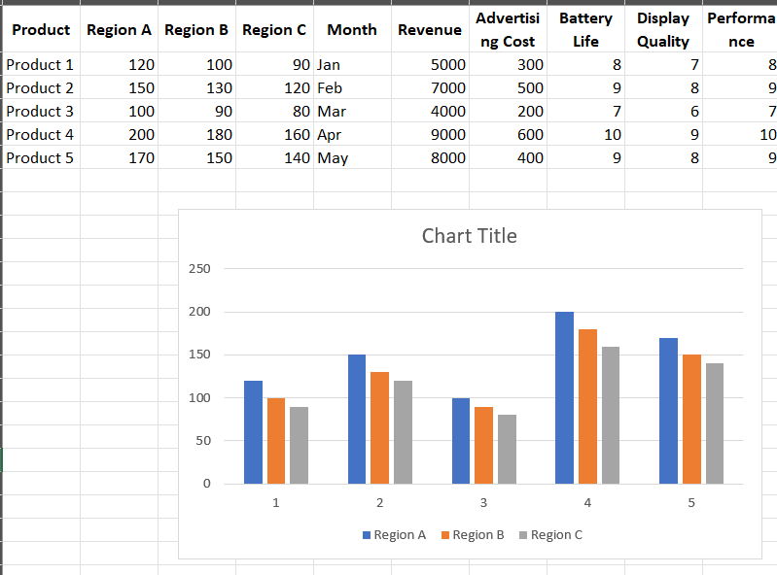

- Line Chart
A line chart connects individual data points with lines, showing how a value changes over a continuous sequence, usually time. It is ideal for highlighting trends, fluctuations, acceleration, or deceleration. Line charts make it easy to visualize growth patterns, seasonality, or periodic changes in data.
Example: Track monthly revenue growth of products.
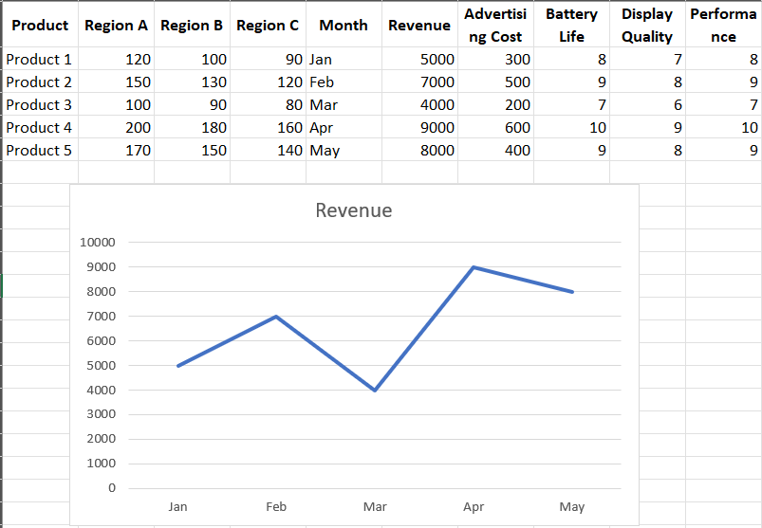

- Pie Chart
A pie chart represents data as slices of a circle, where each slice corresponds to a category’s proportion of the total. It is best used to visualize the relative contribution of a few categories to a whole, allowing quick understanding of percentage distribution. Too many slices can make it confusing.
Example: Show proportion of total revenue contributed by each product in a month
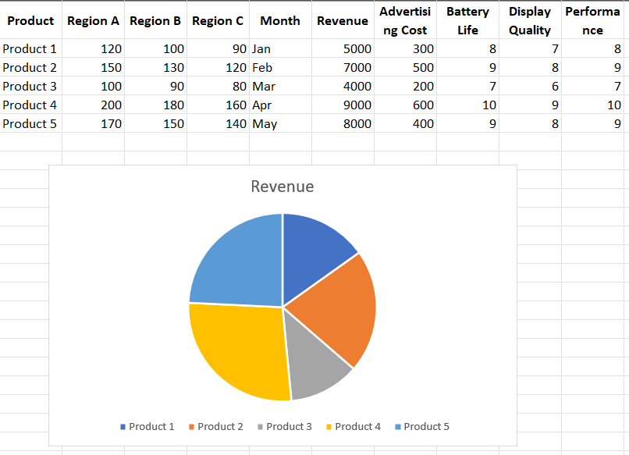

- Bar Chart (Horizontal)
A bar chart uses horizontal bars instead of vertical ones. It is particularly useful when category names are long, as horizontal labels are easier to read. It helps compare values across categories while maintaining clarity in presentation.
Example: Compare Advertising Cost for each product. 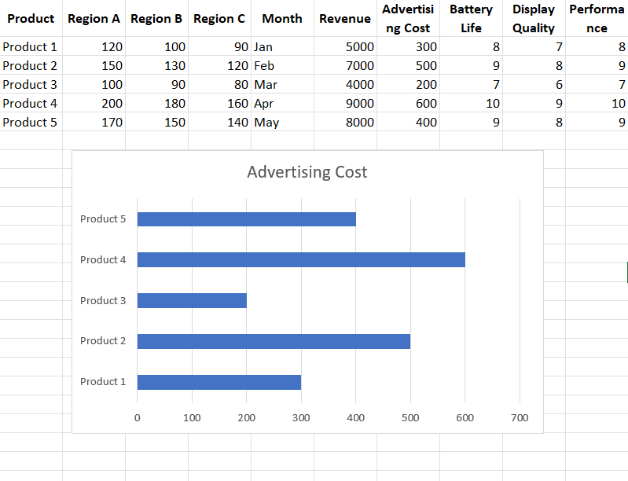

- Scatter Chart
A scatter chart plots data points based on two numerical variables, showing potential relationships or correlations between them. Patterns such as clusters, trends, or outliers become visible, helping in analysis of dependencies or predictive modeling.
Example: Analyze relationship between Advertising Cost and Revenue. 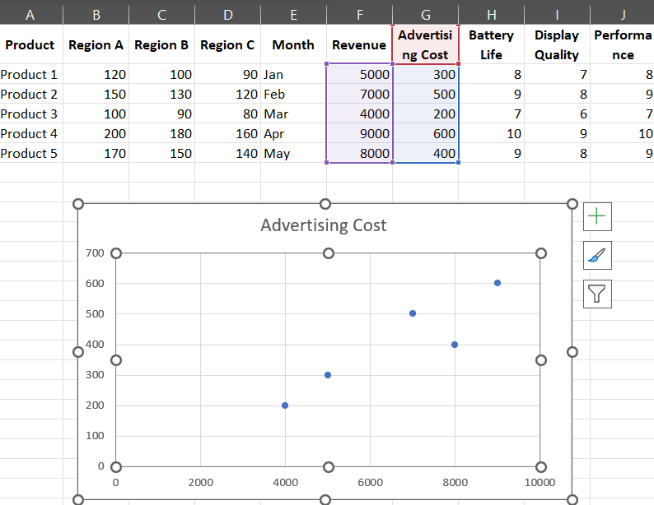
Assignment No.2: Perform Normalization of data (Min-max , Z-score and Decimal scaling).
Aim:
To implement different normalization techniques (Decimal Scaling, Z-Score Normalization, and Min-Max Normalization)
Theory:
Normalization is the process of transforming data values into a standard range, scale, or distribution, which is essential in data preprocessing before applying machine learning or statistical models.
1. Decimal Scaling Normalization
- Values are normalized by moving the decimal point of the data.
- Formula:
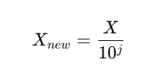
where j is the smallest integer such that all normalized values lie between -1 and 1
2. Z-Score Normalization (Standardization)
- Data is normalized based on mean and standard deviation.
- Formula:
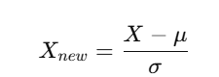
where μ = mean, σ = standard deviation.
- This method centers the data around zero with a standard deviation of one.
3. Min-Max Normalization
- Transforms data into a specific range [newMin, newMax].
- Formula:
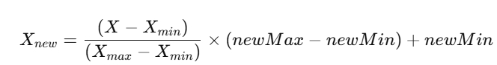
- Preserves relationships but rescales values to a fixed range.

Code :
import csv
import math

def tokenize(line, delimiter=','):
return line.strip().split(delimiter)

def normalize_decimal(value, factor):
return value / (10 ** factor)

def normalize_zscore(value, mean, stddev):
if stddev == 0:
return 0
return (value - mean) / stddev

def normalize_minmax(value, old_min, old_max, new_min, new_max):
if old_max == old_min:
return new_min
return ((value - old_min) / (old_max - old_min)) * (new_max - new_min) + new_min

input_file = "iris.csv"

try:
with open(input_file, 'r') as f:
reader = csv.reader(f)
header = next(reader)
rows = [row for row in reader if len(row) == len(header)]
except FileNotFoundError:
print("Error: Could not open input file.")
exit(1)

cols = len(header)
numeric = [[] for _ in range(cols)]

for row in rows:
for i in range(cols):
try:
numeric[i].append(float(row[i]))
except ValueError:
pass

print("Choose normalization method:")
print("1. Decimal Scaling\n2. Z-Score Normalization\n3. Min-Max Normalization")
choice = int(input("Enter choice: "))

new_min, new_max = 0, 1
if choice == 3:
new_min = float(input("Enter new Min: "))
new_max = float(input("Enter new Max: "))

if choice == 1:
output_file = "out_decimal.csv"
elif choice == 2:
output_file = "out_zscore.csv"
elif choice == 3:
output_file = "out_minmax.csv"
else:
print("Invalid option!")
exit(1)

min_val = [float('inf')] * cols
max_val = [float('-inf')] * cols
mean = [0] * cols
stddev = [0] * cols
scale_factor = [0] * cols

for i in range(cols):
if not numeric[i]:
continue
min_val[i] = min(numeric[i])
max_val[i] = max(numeric[i])
mean[i] = sum(numeric[i]) / len(numeric[i])
stddev[i] = math.sqrt(
sum((v - mean[i]) ** 2 for v in numeric[i]) / len(numeric[i]))
max_abs = max(abs(v) for v in numeric[i])
while max_abs / (10 ** scale_factor[i]) >= 1:
scale_factor[i] += 1

with open(output_file, 'w', newline='') as f:
writer = csv.writer(f)
writer.writerow(header)

for row in rows:
new_row = []
for i in range(cols):
try:
val = float(row[i])
if choice == 1:
norm = normalize_decimal(val, scale_factor[i])
elif choice == 2:
norm = normalize_zscore(val, mean[i], stddev[i])
elif choice == 3:
norm = normalize_minmax(
val, min_val[i], max_val[i], new_min, new_max)
new_row.append(round(norm, 4))
except ValueError:
new_row.append(row[i])
writer.writerow(new_row)

print(f"Normalization complete. Output written to {output_file}")

Input:
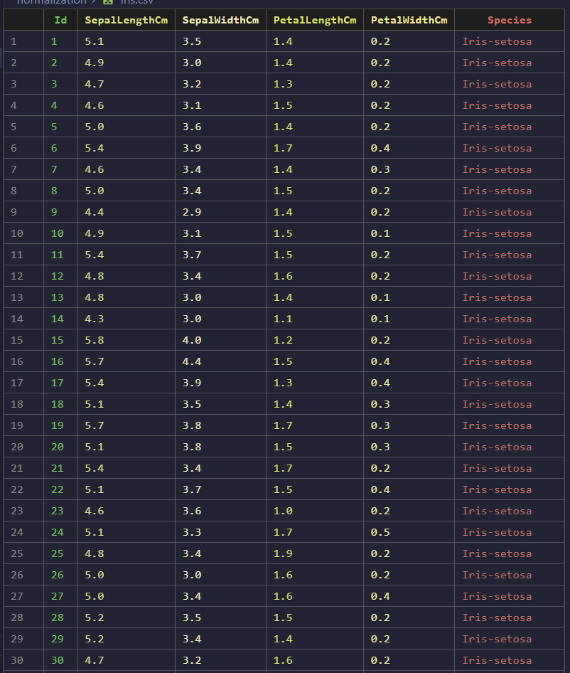

Ouput:
1. Decimal Scaling Normalization
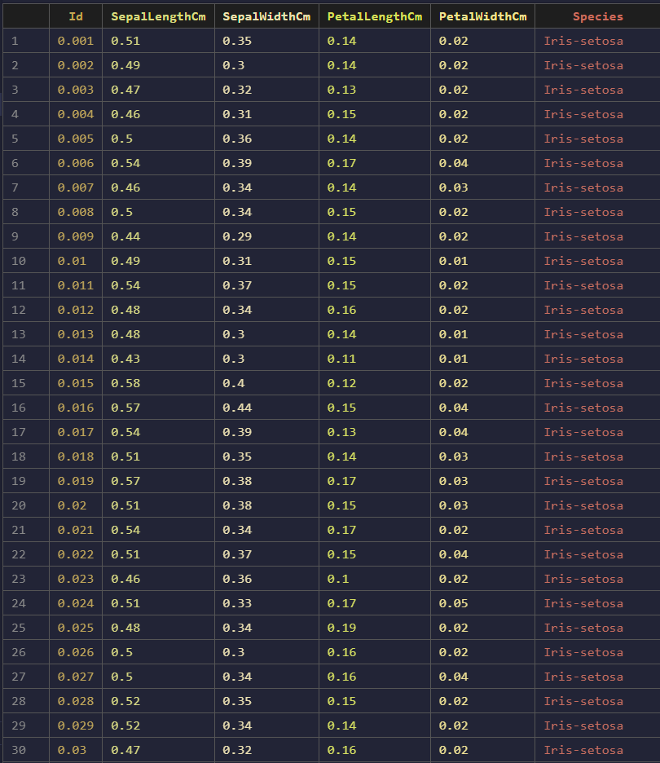

2. Z-Score Normalization
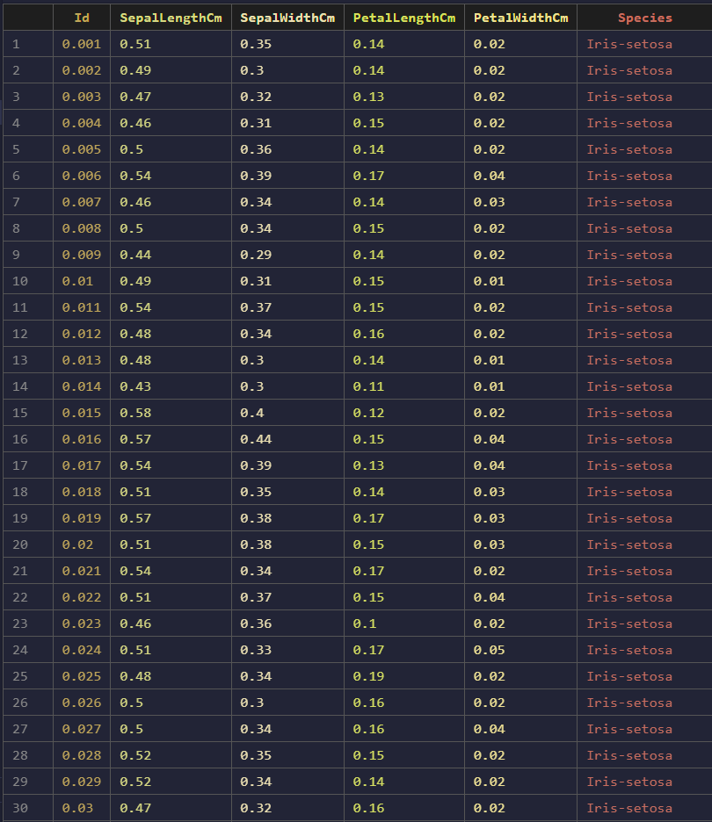

3.Min-Max Normalization
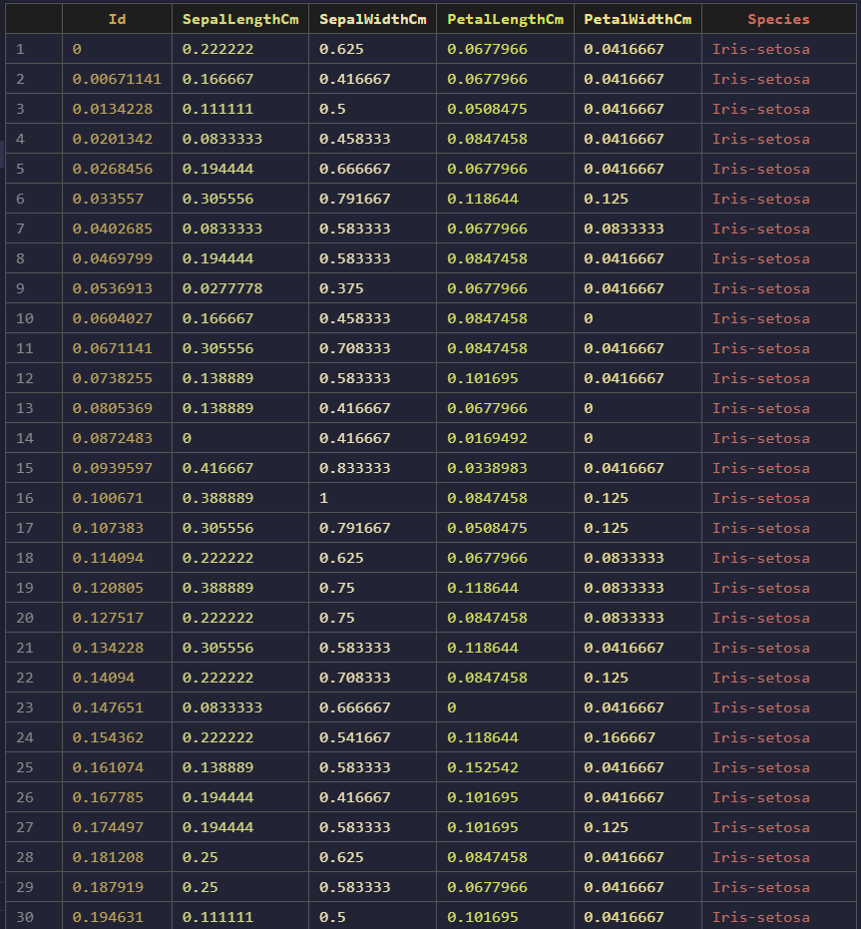

Assignment No. 3: Perform Rollup, drilldown, Slice and dice operations on data.
Aim:
To perform Rollup, Drilldown, Slice, and Dice operations on data using OLAP (Online Analytical Processing) techniques.
Theory:
Online Analytical Processing (OLAP) is a powerful data analysis technique that enables users to interactively explore and analyze multidimensional data from different perspectives. OLAP operations are typically performed on a data cube, which organizes data into dimensions (e.g., Time, Location, Product) and measures (e.g., Sales, Profit).
The four fundamental OLAP operations are:
1. Roll-up (Aggregation)
- Definition: Moves up the hierarchy, summarizing detailed data into higher-level aggregates.
- Example: Aggregating sales data from Day → Month → Quarter → Year.
- Use Case: To analyze overall trends instead of granular details.
2. Drill-down (De-aggregation)
- Definition: The opposite of roll-up; moves down the hierarchy, breaking summarized data into more detailed levels.
- Example: Expanding sales data from Year → Quarter → Month → Day.
- Use Case: To investigate details and uncover finer insights.
3. Slice
- Definition: Fixes a single dimension to a specific value, resulting in a sub-cube.
- Example: Viewing sales data only for Year = 2024.
- Use Case: To focus on a specific dimension or period.
4. Dice
- Definition: Applies multiple conditions across dimensions, producing a smaller sub-cube.
- Example: Sales data for {Year = 2024, Region = “North”, Product = “Laptop”}.
- Use Case: To perform targeted, multi-dimensional analysis.

Code:
import csv

def load_data(filename):
data = []
with open(filename, "r") as file:
reader = csv.DictReader(file)
for row in reader:
row["Sales"] = int(row["Sales"])
data.append(row)
return data

def rollup(data, column):
result = {}
for row in data:
key = row[column]
if key not in result:
result[key] = 0
result[key] += row["Sales"]
return result

def drilldown(data, col1, col2):
result = {}
for row in data:
key = (row[col1], row[col2])
if key not in result:
result[key] = 0
result[key] += row["Sales"]
return result

def slice_data(data, column, value):
result = []
for row in data:
if str(row[column]) == str(value):
result.append(row)
return result

def dice(data, conditions):
result = []
for row in data:
match = True
for col, val in conditions.items():
if str(row[col]) != str(val):
match = False
break
if match:
result.append(row)
return result

def print_table(data, headers):
print("-" * 80)
print(" | ".join(h.ljust(15) for h in headers))
print("-" * 80)

for row in data:
print(" | ".join(str(row[h]).ljust(15) for h in headers))
print("-" * 80)

if __name__ == "__main__":
data = load_data("sales_data.csv")

print("Choose OLAP Operation:")
print("1. Roll-up")
print("2. Drill-down")
print("3. Slice")
print("4. Dice")

choice = int(input("Enter choice (1-4): "))

if choice == 1:
col = input("Enter column for Roll-up (Year/Quarter/Region/Product): ")
result = rollup(data, col)
rows = [{col: k, "Total Sales": v} for k, v in result.items()]
print_table(rows, [col, "Total Sales"])

elif choice == 2:
col1 = input("Enter first column (Year/Region): ")
col2 = input("Enter second column (Quarter/Product): ")
result = drilldown(data, col1, col2)
rows = [{col1: k[0], col2: k[1], "Total Sales": v}
for k, v in result.items()]
print_table(rows, [col1, col2, "Total Sales"])

elif choice == 3:
col = input("Enter column for Slice (Year/Quarter/Region/Product): ")
val = input(f"Enter value for {col}: ")
result = slice_data(data, col, val)
if result:
print_table(result, result[0].keys())
else:
print("No data found!")

elif choice == 4:
n = int(input("How many conditions? "))
conditions = {}
for i in range(n):
col = input("Enter column name: ")
val = input("Enter value: ")
conditions[col] = val
result = dice(data, conditions)
if result:
print_table(result, result[0].keys())
else:
print("No data found!")

else:
print("Invalid choice!")

Input :
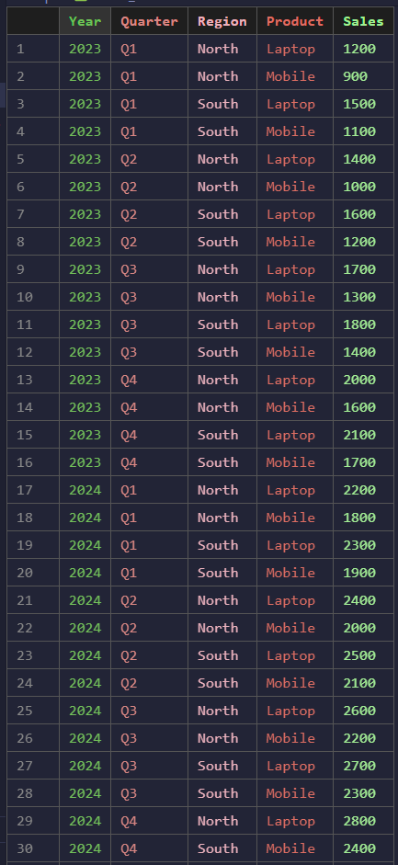
Ouput:
Rollup :
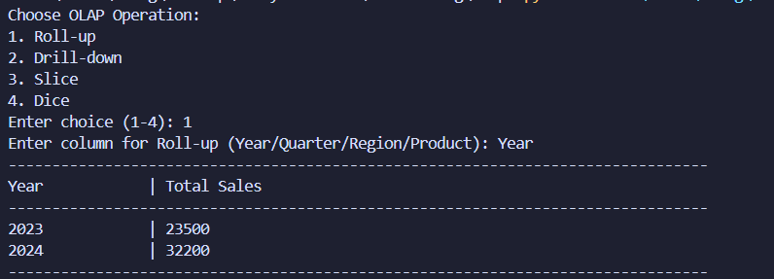

Drill Down :
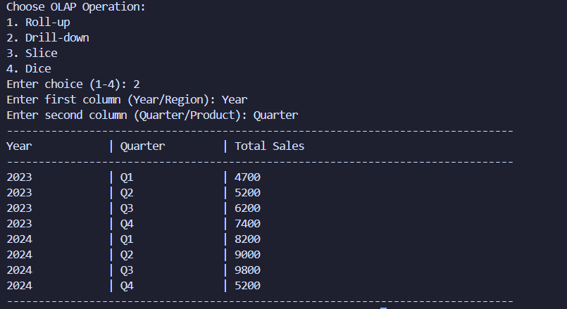

Slice :
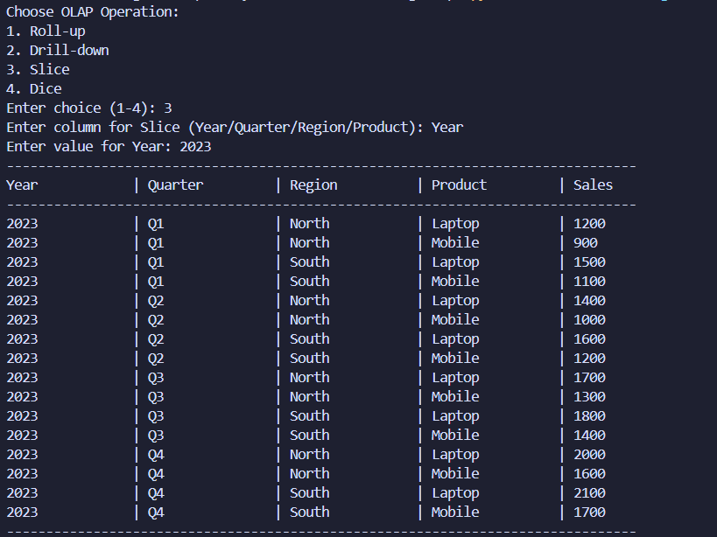

Dice :
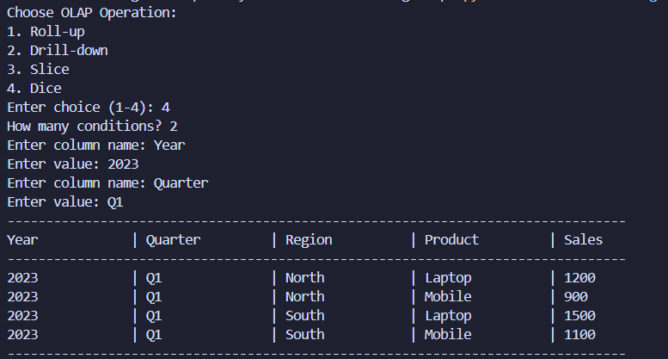

Assignment 4 : Find t and d weight of a data.
Aim :
To compute T-weight and D-weight for categorical data

Theory:
1. T-weight (Typicality Weight)
T-weight measures how typical a generalized term is for the target class.
It is the ratio of the frequency of a generalized term in the target class to the total frequency of all generalized terms in the target class.
2. D-weight (Discriminating Weight)
D-weight measures how well a generalized term discriminates the target class from other classes.
It is the ratio of the frequency of the generalized term in the target class to the total frequency of the generalized term in all classes.

Code :
import csv

with open("data.csv", "r") as f:
reader = csv.reader(f)
header = next(reader)
data = [row for row in reader]

group_cols = header[1:]
rows = []

for row in data:
class_name = row[0]
values = list(map(int, row[1:]))
total = sum(values)
rows.append([class_name] + values + [total])

totals = [sum(col) for col in zip(*[r[1:] for r in rows])]
total_per_class = [r[-1] for r in rows]

out_header = header + ["TOTAL"]
for col in group_cols:
out_header.append(f"T-weight ({col})")
out_header.append(f"D-weight ({col})")

out_rows = []
for r in rows:
class_name = r[0]
values = r[1:-1]
total = r[-1]
new_row = [class_name] + values + [total]

for i, col in enumerate(group_cols):
new_row.append(values[i] / totals[i])
new_row.append(values[i] / total)

out_rows.append(new_row)

print("\n=== Generalized T-weight & D-weight Table ===\n")
print(out_header)
for r in out_rows:
print(r)

with open("output_weights.csv", "w", newline="") as f:
writer = csv.writer(f)
writer.writerow(out_header)
writer.writerows(out_rows)

Input:
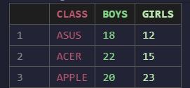
Output:
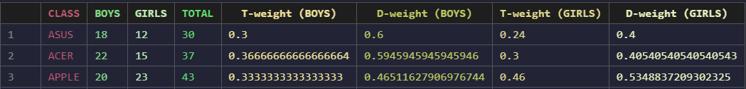

Assignment 5 : Find 5 Number Summary of a Dataset
Aim :
Find 5 Number Summary of a Dataset
Theory:
The five-number summary is a simple but powerful descriptive statistic that summarizes the distribution of a dataset. It consists of:
- Minimum (Min): The smallest value in the dataset.
- First Quartile (Q1): The value below which 25% of the data lies.
- Median (Q2): The middle value of the dataset.
- Third Quartile (Q3): The value below which 75% of the data lies.
- Maximum (Max): The largest value in the dataset.
This summary gives insight into spread, skewness, and presence of outliers. It is often visualized using a Box Plot, where:
- The box spans from Q1 to Q3.
- A line inside the box shows the median.
- "Whiskers" extend to the min and max.
- Outliers (if any) appear as individual points.

Code :
import csv
import matplotlib.pyplot as plt

data = []
with open("data.csv", "r") as file:
reader = csv.reader(file)
next(reader)
for row in reader:
if row:
data.append(float(row[0]))

data.sort()
n = len(data)

def median(values):
m = len(values)
mid = m // 2
if m % 2 == 0:
return (values[mid - 1] + values[mid]) / 2
else:
return values[mid]

minimum = data[0]
maximum = data[-1]
q2 = median(data)

if n % 2 == 0:
lower_half = data[:n//2]
upper_half = data[n//2:]
else:
lower_half = data[:n//2]
upper_half = data[n//2+1:]

q1 = median(lower_half)
q3 = median(upper_half)

print("=== Five Number Summary ===")
print(f"Minimum : {minimum}")
print(f"Q1 (25%) : {q1}")
print(f"Median (Q2) : {q2}")
print(f"Q3 (75%) : {q3}")
print(f"Maximum : {maximum}")

plt.boxplot(data)
plt.title("Box Plot - Five Number Summary")
plt.xlabel("Values")
plt.show()

Input:
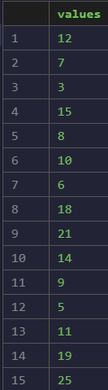
Ouput:
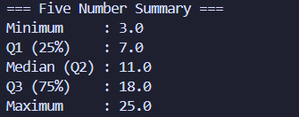
Box Plot:
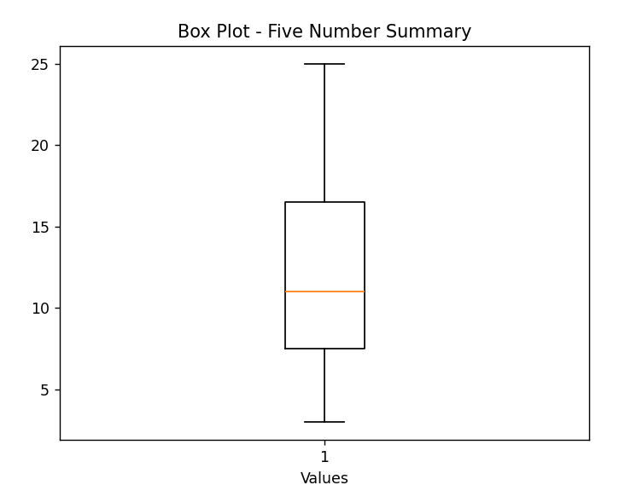

Assignment 6 : Using Apriori algorithm find Frequent items sets and Association rules.
Aim :
To implement the Apriori algorithm, find frequent itemsets for a transactional dataset, and generate association rules
Theory:
Association rule mining uncovers relationships between items that co-occur in a collection of transactions. The goal is to find item combinations that appear regularly (frequent itemsets) and to express reliable implication rules of the form A → B, meaning “when A occurs, B is likely to occur as well.” This technique is commonly used in market-basket analysis, recommendation systems, and exploratory data mining.
Transaction : A transaction is a single record containing a set of items purchased together.
Itemset : An itemset is any set of one or more items considered together as a group.
Support count : Support_count(X) is the number of transactions that contain itemset X.
Support : Support(X) is the fraction (or probability) of all transactions that include X.
Use support to filter out itemsets that are too rare to be interesting.
Frequent itemset : A frequent itemset is an itemset whose support meets or exceeds a user-defined threshold.Frequent itemsets are considered for rule generation because they appear often enough.
X is frequent ⇔ support(X) ≥ min_support
Association rule:
An association rule is an implication A → B meaning that when items A appear, items B tend to appear too. A and B must be disjoint, and rules are evaluated by support and confidence.
Confidence:
Confidence(A → B) is the conditional probability that B appears in a transaction given A appears. It measures how often the rule is correct when A occurs.
Lift :
Lift(A → B) measures how much more often A and B occur together than if they were independent.
Code :
import pandas as pd

df = pd.read_csv('data.csv')

def parse_data(df):
transactions = []
for i in range(len(df)):
row = df.iloc[i]
transaction = []
for item in row:
if pd.notna(item) and item.replace(' ', '') != '':
transaction.append(str(item))
transactions.append(transaction)
return transactions

def apriori(transactions, min_support):
if not (0 < min_support <= 1):
raise ValueError("min_support must be between 0 and 1")

n = len(transactions)
min_cnt = max(1, (int)(min_support*n))

item_cnt = {}
for t in transactions:
for it in t:
if it not in item_cnt:
item_cnt[it] = 1
else:
item_cnt[it] += 1

l1 = [frozenset([it]) for it, cnt in item_cnt.items() if cnt >= min_cnt]
supports = {}
freq_itemsets = []
for it in l1:
cnt = item_cnt[list(it)[0]]
support = cnt/n
supports[it] = support
freq_itemsets.append((it, cnt, support))

k = 2
lk_1 = l1
while len(lk_1) > 0:
candidates = set()
for i in range(len(lk_1)):
for j in range(i+1, len(lk_1)):
combined = lk_1[i] | lk_1[j]
if len(combined) == k:
candidates.add(combined)

candidates = list(candidates)
pruned_candidates = []
for c in candidates:
flag = True
for it in c:
subset = c - frozenset([it])
if subset not in lk_1:
flag = False
break

if flag:
pruned_candidates.append(c)

candidates = pruned_candidates

counts = {}
for t in transactions:
tset = frozenset(t)
for c in candidates:
if c.issubset(tset):
if c not in counts:
counts[c] = 1
else:
counts[c] += 1

lk = [c for c in candidates if c in counts and counts[c] >= min_cnt]
for it in lk:
support = counts[it]/n
supports[it] = support
freq_itemsets.append((it, counts[it], support))

lk_1 = lk
k += 1

return freq_itemsets, supports

def get_association_rules(freq_itemsets, min_confidence, transactions):
support_lookup = {itemset: support for itemset,
count, support in freq_itemsets}
rules = []
n = len(transactions)
for itemset, count, support in freq_itemsets:
if len(itemset) > 1:
for item in itemset:
antecedent = frozenset([item])
consequent = itemset - antecedent
if len(consequent) > 0:
antecedent_count = sum(
1 for t in transactions if antecedent.issubset(frozenset(t)))
confidence = count / antecedent_count
if confidence >= min_confidence:
support_consequent = support_lookup.get(consequent, 0)
if support_consequent > 0:
lift = confidence / support_consequent
else:
lift = 0
rules.append(
(antecedent, consequent, confidence, lift))
return rules

def main():
transactions = parse_data(df)

print("Parsed Transactions: ")
for transaction in transactions[0:5]:
print(transaction)
print("...")

min_support = float(input("Enter minimum support (0-1): "))
freq_itemsets, supports = apriori(transactions, min_support)

print("\nFrequent Itemsets:")
for itemset, count, support in freq_itemsets:
print(
f"Itemset: {set(itemset)}, Count: {count}, Support: {support:.4f}")

fi_rows = []
for itemset, count, support in freq_itemsets:
fi_rows.append({
"itemset": "{" + f"{','.join(sorted(list(itemset)))}" + "}",
"count": count,
"support": f"{support:.6f}",
})
pd.DataFrame(fi_rows).to_csv("frequent_itemsets.csv", index=False)
print("Saved frequent itemsets to: frequent_itemsets.csv")

if not freq_itemsets:
print("No frequent itemsets found with the given minimum support.")
else:
print(f"Total frequent itemsets found: {len(freq_itemsets)}\n")

min_confidence = float(input("Enter minimum confidence (0-1): "))
rules = get_association_rules(freq_itemsets, min_confidence, transactions)
print("\nAssociation Rules:")
for antecedent, consequent, confidence, lift in rules:
print(f"Rule: {set(antecedent)} -> {set(consequent)}, "
f"Confidence: {confidence:.4f}, Lift: {lift:.4f}")

ar_rows = []
for antecedent, consequent, confidence, lift in rules:
ar_rows.append({
"antecedent": "{" + f"{','.join(sorted(list(antecedent)))}" + "}",
"consequent": "{" + f"{','.join(sorted(list(consequent)))}" + "}",
"confidence": f"{confidence:.6f}",
"lift": f"{lift:.6f}",
})
pd.DataFrame(ar_rows).to_csv("association_rules.csv", index=False)
print("Saved association rules to: association_rules.csv")

if not rules:
print("No association rules found with the given minimum confidence.")
else:
print(f"Total rules found: {len(rules)}")

if __name__ == "__main__":
main()

Input:
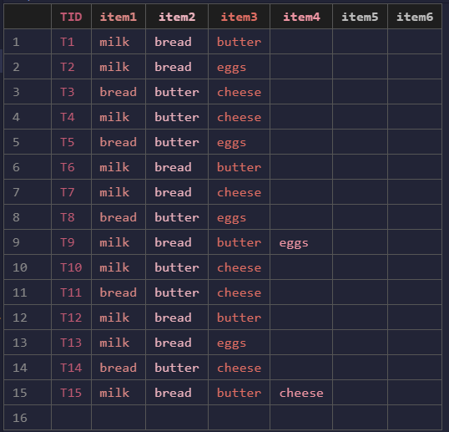
Output:
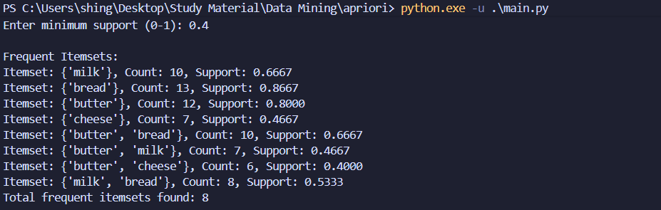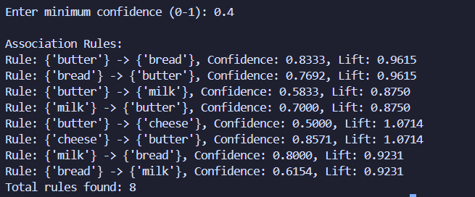
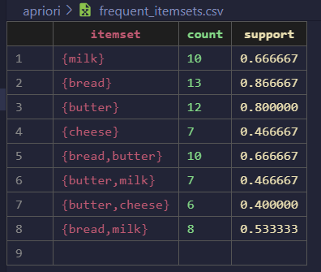
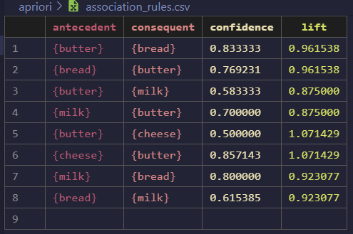

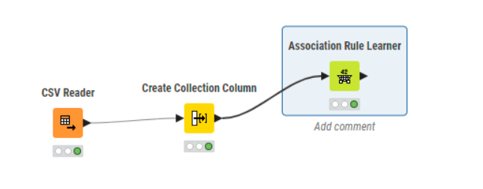
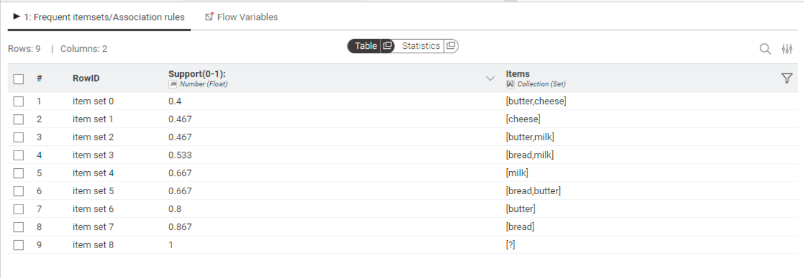
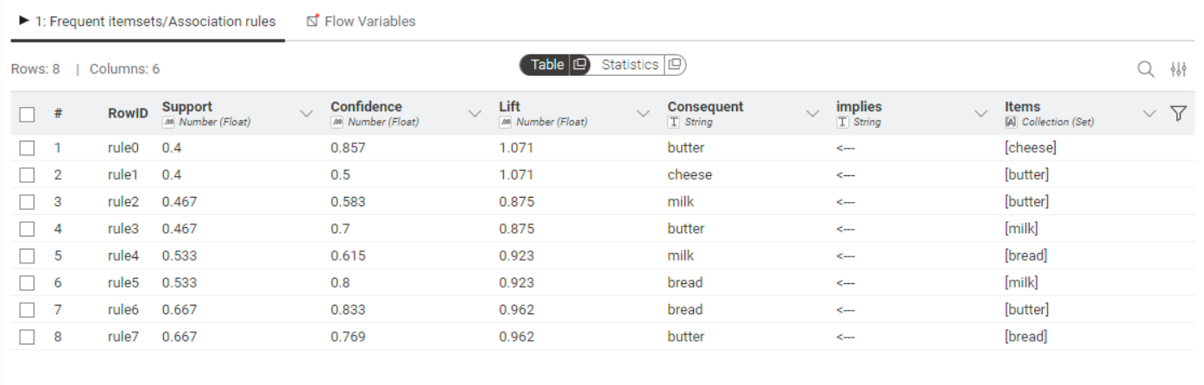
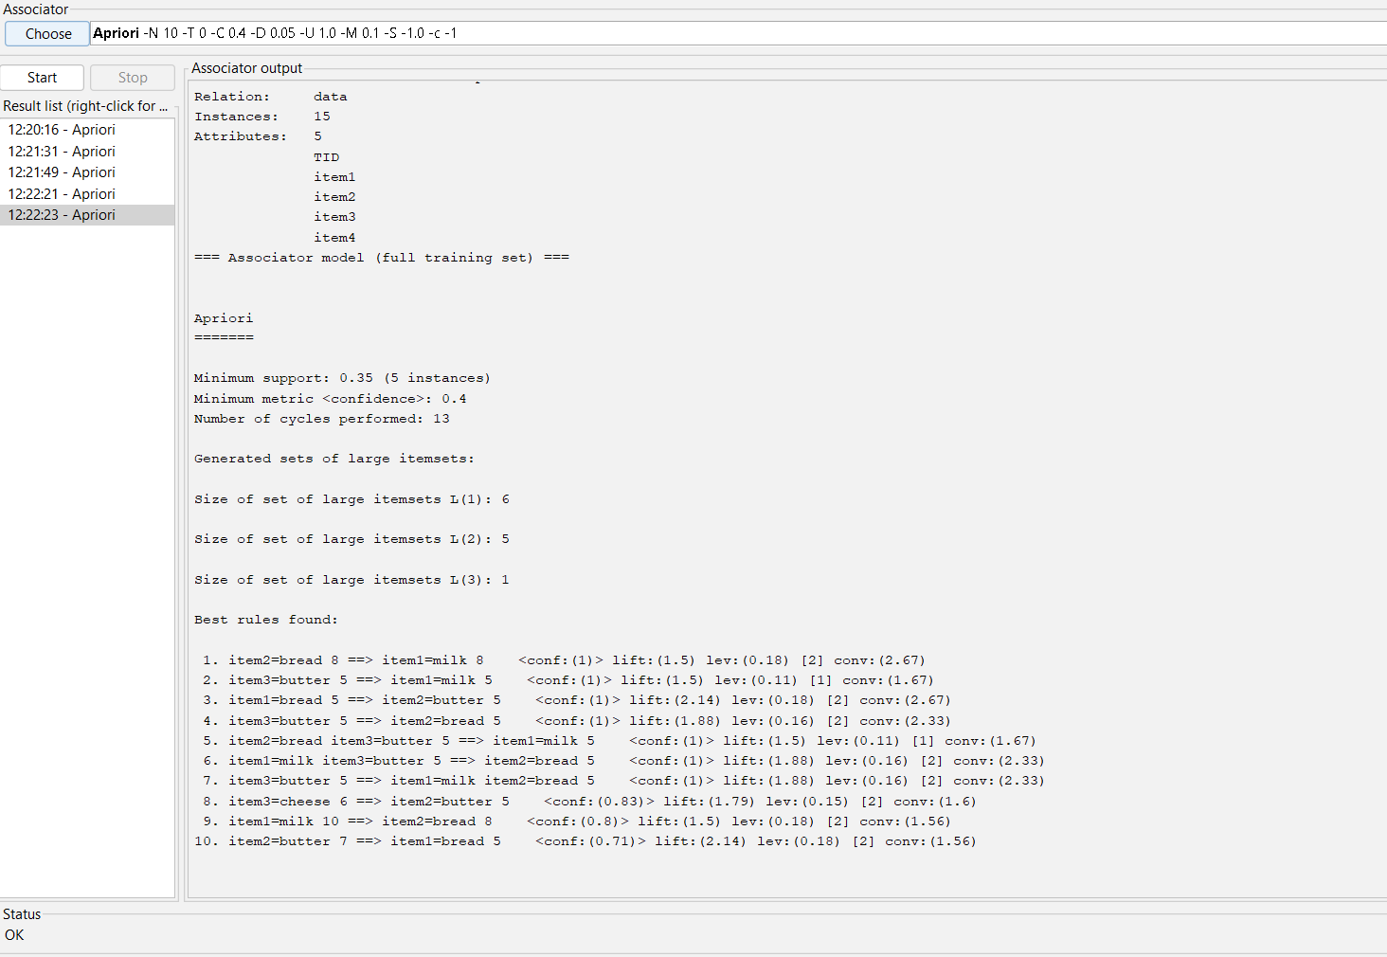

Assignment 7 : Find correlation between items/entities

Aim :
To calculate and analyze the correlation between different items or entities in a dataset to determine the strength and direction of their relationship.
Theory:
Correlation is a statistical measure that describes the degree to which two variables move in relation to each other. It helps in understanding how one variable changes when another variable changes.
The correlation coefficient (r) quantifies this relationship and always lies between –1 and +1
- r = +1: Perfect positive correlation (both variables increase together)
- r = –1: Perfect negative correlation (one increases, the other decreases)
- r = 0: No correlation (no linear relationship between variables
Where,
- $n$= number of pairs of scores
- $x$= values of first variable
- $y$= values of second variable

Code :
import pandas as pd
import math

df = pd.read_csv('data.csv')

item_cols = [col for col in df.columns if col != 'TID']
pearson_results = []

for i in range(len(item_cols)):
for j in range(i+1, len(item_cols)):
col1 = item_cols[i]
col2 = item_cols[j]
x = df[col1].values
y = df[col2].values
n = len(x)
x_mean = sum(x) / n
y_mean = sum(y) / n
numerator = sum((xi - x_mean) * (yi - y_mean) for xi, yi in zip(x, y))
denominator = math.sqrt(
sum((xi - x_mean) ** 2 for xi in x) * sum((yi - y_mean) ** 2 for yi in y)
)
r = numerator / denominator if denominator != 0 else float('nan')
pearson_results.append({
'Item 1': col1,
'Item 2': col2,
'Pearson Correlation': r
})
print(f"Pearson correlation between {col1} and {col2}: {r}")

pearson_df = pd.DataFrame(pearson_results)
pearson_df.to_csv('pearson_correlation_output.csv', index=False)

Input:
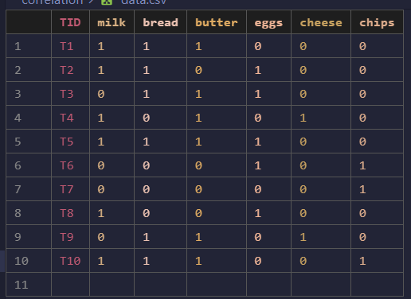
Output:
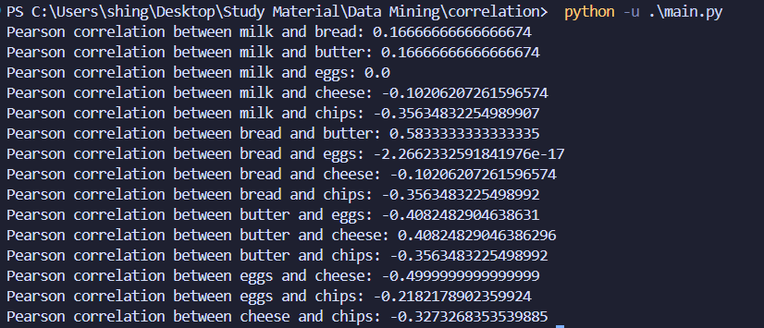
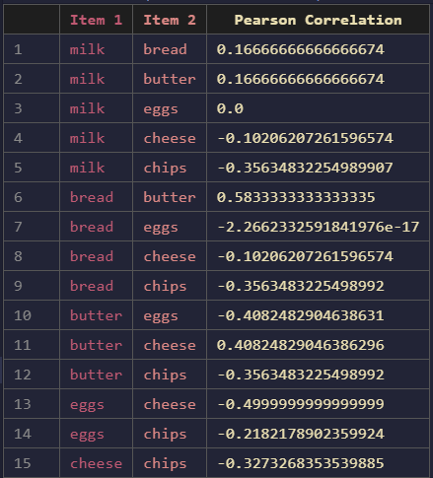
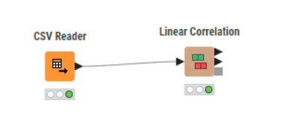

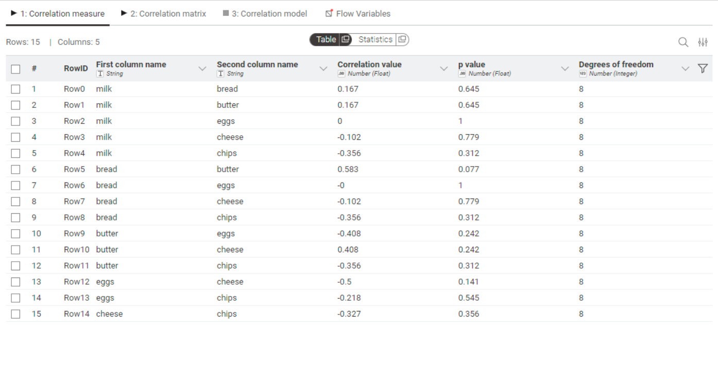
Assignment 8 : Implement different types of clustering
Aim :
To study and implement different clustering techniques used in data mining.
Theory :
Clustering : Unsupervised grouping of records so that intra-cluster similarity is high and inter-cluster similarity is low.
In data mining, distance (or similarity) is the fundamental concept used to decide which records belong together. Choice of distance metric and preprocessing (scaling, encoding) strongly affects results.
Euclidean distance : Geometric straight-line distance (continuous numeric features).
Partition methods :
- K-Means: minimizes sum of squared Euclidean distances to centroids. Best for numeric data and roughly spherical clusters.
- K-Medoids (PAM): uses actual data points as centers (medoids); works with any distance matrix and is more robust to outliers.
Hierarchical clustering :
- Builds a dendrogram from pairwise distances using a linkage rule (agglomerative — bottom up — is most common). Choose linkage based on desired cluster shape:
  - Single linkage (nearest neighbour):
Merges clusters using the closest pair of points — can produce “chain-like” clusters; sensitive to noise.
  - Complete linkage (farthest neighbour):
Uses the farthest pair — produces compact, tight clusters; more sensitive to outliers than average linkage.
  - Average linkage:
Balances single and complete — tends to produce clusters of moderate shape and size.
Density-based :
- DBSCAN: Grows clusters from core points using ε (neighborhood radius) and minPts (minimum neighbors). Works with arbitrary distance metrics; good for arbitrary-shaped clusters and noise handling.
Code :
K-means
import random
import pandas as pd

path = "data.csv"
out_path = "k-means.csv"
random.seed(42)

df = pd.read_csv(path)
num_cols = list(df.select_dtypes(include="number").columns)
if not num_cols:
raise SystemExit("No numeric columns found in the CSV.")

df_num = df[num_cols].dropna()
rows = df_num.values.tolist()
indexes = df_num.index.tolist()

try:
k = int(input("Enter number of clusters k: ").strip())
except Exception:
k = 3
if k < 1:
k = 1
if k > len(rows):
k = len(rows)

def euclid(a, b):
return sum((x - y) ** 2 for x, y in zip(a, b)) ** 0.5

def write_step_matrix(step_name, rows_data, centers, csv_path):
labels = [f"p{i+1}" for i in range(len(rows_data))]
matrix = []
for i in range(len(rows_data)):
row_vals = []
for j in range(len(rows_data)):
if i == j:
row_vals.append(0.0)
elif i > j:
row_vals.append(euclid(rows_data[i], rows_data[j]))
else:
row_vals.append("")
matrix.append(row_vals)

with open(csv_path, "a", newline="") as f:
f.write(f"Step:,{step_name}\n")
f.write("," + ",".join(labels) + "\n")
for i in range(len(rows_data)):
values = [
(f"{v:.4f}" if isinstance(v, float) else str(v)) for v in matrix[i]
]
f.write(labels[i] + "," + ",".join(values) + "\n")

for ci, c in enumerate(centers):
dists = [f"{euclid(c, rows_data[j]):.4f}" for j in range(
len(rows_data))]
f.write(f"c{ci+1}," + ",".join(dists) + "\n")
f.write("\n")

def mean_point(points):
n = len(points)
dim = len(points[0])
return [sum(p[i] for p in points) / n for i in range(dim)]

centroids = [list(rows[i]) for i in random.sample(range(len(rows)), k)]
print("Initial centers:")
for idx, c in enumerate(centroids):
print(f" Center {idx}: " + ", ".join(f"{x:.4f}" for x in c))

steps_csv_path = "k-means-out.csv"
open(steps_csv_path, "w").close()
write_step_matrix("init", rows, centroids, steps_csv_path)

max_iters = 1000
for step in range(max_iters):
clusters = [[] for _ in range(k)]
labels = []
all_dists = []
for row_idx, x in enumerate(rows):
dists = [euclid(x, c) for c in centroids]
idx = dists.index(min(dists))
labels.append(idx)
clusters[idx].append(x)
all_dists.append(dists)

write_step_matrix(f"iter_{step}", rows, centroids, steps_csv_path)

new_centroids = []
changed = False
for i in range(k):
if clusters[i]:
new_c = mean_point(clusters[i])
else:
new_c = list(rows[random.randrange(len(rows))])
new_centroids.append(new_c)
if not changed:
for a, b in zip(new_c, centroids[i]):
if abs(a - b) > 1e-8:
changed = True
break

centroids = new_centroids
if not changed:
break

counts = [labels.count(i) for i in range(k)]

df_out = df.copy()
df_out["cluster"] = pd.NA
for idx, lbl in zip(indexes, labels):
df_out.at[idx, "cluster"] = int(lbl)

df_out.to_csv(out_path, index=False)

print("\nFinal cluster sizes:", counts)
print("Final centroids:")
for i, c in enumerate(centroids):
print(f" C{i}: " + ", ".join(f"{x:.4f}" for x in c))

DBSCAN
import pandas as pd
import matplotlib.pyplot as plt
import itertools

DATA_PATH = "data.csv"
OUT_PATH = "dbscan.csv"

def dist(a, b):
return sum((x - y) ** 2 for x, y in zip(a, b))**0.5

def region_query(rows, point_idx, eps2):
p = rows[point_idx]
neighbors = []
for j, q in enumerate(rows):
if dist(p, q) <= eps2:
neighbors.append(j)
return neighbors

def dbscan(rows, eps, min_samples):
n = len(rows)
labels = [None] * n
cluster_id = 0
eps2 = eps * eps

for i in range(n):
if labels[i] is not None:
continue

neighbors = region_query(rows, i, eps2)
if len(neighbors) < min_samples:
labels[i] = -1
continue

labels[i] = cluster_id
seeds = neighbors.copy()
k = 0
while k < len(seeds):
j = seeds[k]
if labels[j] is None:
labels[j] = cluster_id
j_neighbors = region_query(rows, j, eps2)
if len(j_neighbors) >= min_samples:
for nb in j_neighbors:
if nb not in seeds:
seeds.append(nb)
elif labels[j] == -1:
labels[j] = cluster_id
k += 1

cluster_id += 1

return labels

def main():
df = pd.read_csv(DATA_PATH)
num_cols = list(df.select_dtypes(include="number").columns)
if not num_cols:
raise SystemExit("No numeric columns found in the CSV.")

df_num = df[num_cols].dropna()
rows = df_num.values.tolist()
indexes = df_num.index.tolist()

try:
eps = float(input("Enter neighborhood radius eps : ").strip())
except Exception:
eps = 0.5
try:
min_samples = int(input("Enter min_samples : ").strip())
except Exception:
min_samples = 5
if eps <= 0:
eps = 0.5
if min_samples < 1:
min_samples = 1

labels = dbscan(rows, eps, min_samples)

df_out = df.copy()
df_out["cluster"] = pd.NA
for idx, lbl in zip(indexes, labels):
df_out.at[idx, "cluster"] = int(lbl)
df_out.to_csv(OUT_PATH, index=False)

n_noise = sum(1 for l in labels if l == -1)
cluster_ids = sorted(set(l for l in labels if l is not None and l >= 0))
counts = {cid: labels.count(cid) for cid in cluster_ids}

print(f"\nDBSCAN results (eps={eps}, min_samples={min_samples}):")
print("Clusters and sizes:")
for cid in cluster_ids:
print(f" Cluster {cid}: {counts[cid]} points")
print(f" Noise: {n_noise} points")

if __name__ == "__main__":
main()

Heirarchial Single Linkage
import pandas as pd

path = "data.csv"
out_path = "heirarchial-single.csv"
matrix_path = "heirarchial-single-steps.csv"

df = pd.read_csv(path)
num_cols = list(df.select_dtypes(include="number").columns)
if not num_cols:
raise SystemExit("No numeric columns found in the CSV.")

df_num = df[num_cols].dropna()
rows = df_num.values.tolist()
indexes = df_num.index.tolist()

def dist(a, b):
return sum((x - y) ** 2 for x, y in zip(a, b)) ** 0.5

def write_step_matrix(step_name, clusters_data, csv_path):
labels = ["|".join(f"p{i+1}" for i in sorted(cluster)) for cluster in clusters_data]
n = len(clusters_data)
matrix = []
for i in range(n):
row_vals = []
for j in range(n):
if i == j:
row_vals.append(0.0)
elif i > j:
min_d = float("inf")
for a in clusters_data[i]:
for b in clusters_data[j]:
d = dist(rows[a], rows[b])
if d < min_d:
min_d = d
row_vals.append(min_d)
else:
row_vals.append("")
matrix.append(row_vals)
with open(csv_path, "a", newline="") as f:
f.write(f"Grouping:,{step_name}\n")
f.write("," + ",".join(labels) + "\n")
for i in range(n):
values = [(f"{v:.4f}" if isinstance(v, float) else str(v)) for v in matrix[i]]
f.write(labels[i] + "," + ",".join(values) + "\n")
f.write("\n")

clusters = [[i] for i in range(len(rows))]
open(matrix_path, "w").close()
write_step_matrix("initial", clusters, matrix_path)
labels_print = [f"p{i+1}" for i in range(len(rows))]
print("Grouping: initial")
for gi, g in enumerate(clusters):
print(f"group{gi+1}: " + "|".join(labels_print[idx] for idx in g))
print()

def cluster_distance(c1, c2):
m = float("inf")
for i in c1:
for j in c2:
d = dist(rows[i], rows[j])
if d < m:
m = d
return m

step_idx = 1
while len(clusters) > 1:
best_i, best_j, best_d = None, None, float("inf")
for i in range(len(clusters)):
for j in range(i + 1, len(clusters)):
d = cluster_distance(clusters[i], clusters[j])
if d < best_d:
best_d = d
best_i, best_j = i, j
merged = clusters[best_i] + clusters[best_j]
new_clusters = []
for t, c in enumerate(clusters):
if t != best_i and t != best_j:
new_clusters.append(c)
new_clusters.append(merged)
clusters = new_clusters
write_step_matrix(f"grouping_{step_idx}", clusters, matrix_path)
print(f"Grouping: grouping_{step_idx} (distance merged: {best_d:.4f})")
for gi, g in enumerate(clusters):
print(f"group{gi+1}: " + "|".join(labels_print[idx] for idx in g))
print()
step_idx += 1

labels = [None] * len(rows)
for cid, c in enumerate(clusters):
for idx in c:
labels[idx] = cid

df_out = df.copy()
df_out["cluster"] = pd.NA
for idx, lbl in zip(indexes, labels):
df_out.at[idx, "cluster"] = int(lbl)
df_out.to_csv(out_path, index=False)

print("Final clusters:")
for gi, g in enumerate(clusters):
print(f"cluster{gi}: " + "|".join(labels_print[idx] for idx in g))

Heirarchial Complete Linkage
import pandas as pd

path = "data.csv"
out_path = "heirarchial-complete.csv"
matrix_path = "heirarchial-complete-steps.csv"

df = pd.read_csv(path)
num_cols = list(df.select_dtypes(include="number").columns)
if not num_cols:
raise SystemExit("No numeric columns found in the CSV.")

df_num = df[num_cols].dropna()
rows = df_num.values.tolist()
indexes = df_num.index.tolist()

def dist(a, b):
return sum((x - y) ** 2 for x, y in zip(a, b)) ** 0.5

def write_step_matrix(step_name, clusters_data, csv_path):
labels = ["|".join(f"p{i+1}" for i in sorted(cluster)) for cluster in clusters_data]
n = len(clusters_data)
matrix = []
for i in range(n):
row_vals = []
for j in range(n):
if i == j:
row_vals.append(0.0)
elif i > j:
max_d = 0.0
for a in clusters_data[i]:
for b in clusters_data[j]:
d = dist(rows[a], rows[b])
if d > max_d:
max_d = d
row_vals.append(max_d)
else:
row_vals.append("")
matrix.append(row_vals)
with open(csv_path, "a", newline="") as f:
f.write(f"Grouping:,{step_name}\n")
f.write("," + ",".join(labels) + "\n")
for i in range(n):
values = [(f"{v:.4f}" if isinstance(v, float) else str(v)) for v in matrix[i]]
f.write(labels[i] + "," + ",".join(values) + "\n")
f.write("\n")

clusters = [[i] for i in range(len(rows))]
open(matrix_path, "w").close()
write_step_matrix("initial", clusters, matrix_path)
labels_print = [f"p{i+1}" for i in range(len(rows))]
print("Grouping: initial")
for gi, g in enumerate(clusters):
print(f"group{gi+1}: " + "|".join(labels_print[idx] for idx in g))

def cluster_distance_complete(c1, c2):
m = 0.0
for i in c1:
for j in c2:
d = dist(rows[i], rows[j])
if d > m:
m = d
return m

step_idx = 1
while len(clusters) > 1:
best_i, best_j, best_d = None, None, -1.0
for i in range(len(clusters)):
for j in range(i + 1, len(clusters)):
d = cluster_distance_complete(clusters[i], clusters[j])
if d > best_d:
best_d = d
best_i, best_j = i, j
merged = clusters[best_i] + clusters[best_j]
new_clusters = []
for t, c in enumerate(clusters):
if t != best_i and t != best_j:
new_clusters.append(c)
new_clusters.append(merged)
clusters = new_clusters
write_step_matrix(f"grouping_{step_idx}", clusters, matrix_path)
print(f"Grouping: grouping_{step_idx} (distance merged: {best_d:.4f})")
for gi, g in enumerate(clusters):
print(f"group{gi+1}: " + "|".join(labels_print[idx] for idx in g))
print()
step_idx += 1

labels = [None] * len(rows)
for cid, c in enumerate(clusters):
for idx in c:
labels[idx] = cid

df_out = df.copy()
df_out["cluster"] = pd.NA
for idx, lbl in zip(indexes, labels):
df_out.at[idx, "cluster"] = int(lbl)
df_out.to_csv(out_path, index=False)

print("Final clusters:")
for gi, g in enumerate(clusters):
print(f"cluster{gi}: " + "|".join(labels_print[idx] for idx in g))

Heirarchial Average Linkage
import pandas as pd

path = "data.csv"
out_path = "heirarchial-average.csv"
matrix_path = "heirarchial-average-steps.csv"

df = pd.read_csv(path)
num_cols = list(df.select_dtypes(include="number").columns)
if not num_cols:
raise SystemExit("No numeric columns found in the CSV.")

df_num = df[num_cols].dropna()
rows = df_num.values.tolist()
indexes = df_num.index.tolist()

def dist(a, b):
return sum((x - y) ** 2 for x, y in zip(a, b)) ** 0.5

def average_linkage_distance(c1, c2):
total = 0.0
count = 0
for i in c1:
for j in c2:
total += dist(rows[i], rows[j])
count += 1
return total / count if count > 0 else 0.0

def write_step_matrix(step_name, clusters_data, csv_path):
labels = ["|".join(f"p{i+1}" for i in sorted(cluster)) for cluster in clusters_data]
n = len(clusters_data)
matrix = []
for i in range(n):
row_vals = []
for j in range(n):
if i == j:
row_vals.append(0.0)
elif i > j:
d = average_linkage_distance(clusters_data[i], clusters_data[j])
row_vals.append(d)
else:
row_vals.append("")
matrix.append(row_vals)
with open(csv_path, "a", newline="") as f:
f.write(f"Grouping:,{step_name}\n")
f.write("," + ",".join(labels) + "\n")
for i in range(n):
values = [(f"{v:.4f}" if isinstance(v, float) else str(v)) for v in matrix[i]]
f.write(labels[i] + "," + ",".join(values) + "\n")
f.write("\n")

clusters = [[i] for i in range(len(rows))]
open(matrix_path, "w").close()
write_step_matrix("initial", clusters, matrix_path)
labels_print = [f"p{i+1}" for i in range(len(rows))]
print("Grouping: initial")
for gi, g in enumerate(clusters):
print(f"group{gi+1}: " + "|".join(labels_print[idx] for idx in g))

step_idx = 1
while len(clusters) > 1:
best_i, best_j, best_d = None, None, float("inf")
for i in range(len(clusters)):
for j in range(i + 1, len(clusters)):
d = average_linkage_distance(clusters[i], clusters[j])
if d < best_d:
best_d = d
best_i, best_j = i, j
merged = clusters[best_i] + clusters[best_j]
new_clusters = []
for t, c in enumerate(clusters):
if t != best_i and t != best_j:
new_clusters.append(c)
new_clusters.append(merged)
clusters = new_clusters
write_step_matrix(f"grouping_{step_idx}", clusters, matrix_path)
print(f"Grouping: grouping_{step_idx} (distance merged: {best_d:.4f})")
for gi, g in enumerate(clusters):
print(f"group{gi+1}: " + "|".join(labels_print[idx] for idx in g))
print()
step_idx += 1

labels = [None] * len(rows)
for cid, c in enumerate(clusters):
for idx in c:
labels[idx] = cid

df_out = df.copy()
df_out["cluster"] = pd.NA
for idx, lbl in zip(indexes, labels):
df_out.at[idx, "cluster"] = int(lbl)
df_out.to_csv(out_path, index=False)

print("Final clusters:")
for gi, g in enumerate(clusters):
print(f"cluster{gi}: " + "|".join(labels_print[idx] for idx in g))

Input:
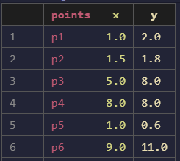
Output:
K-means
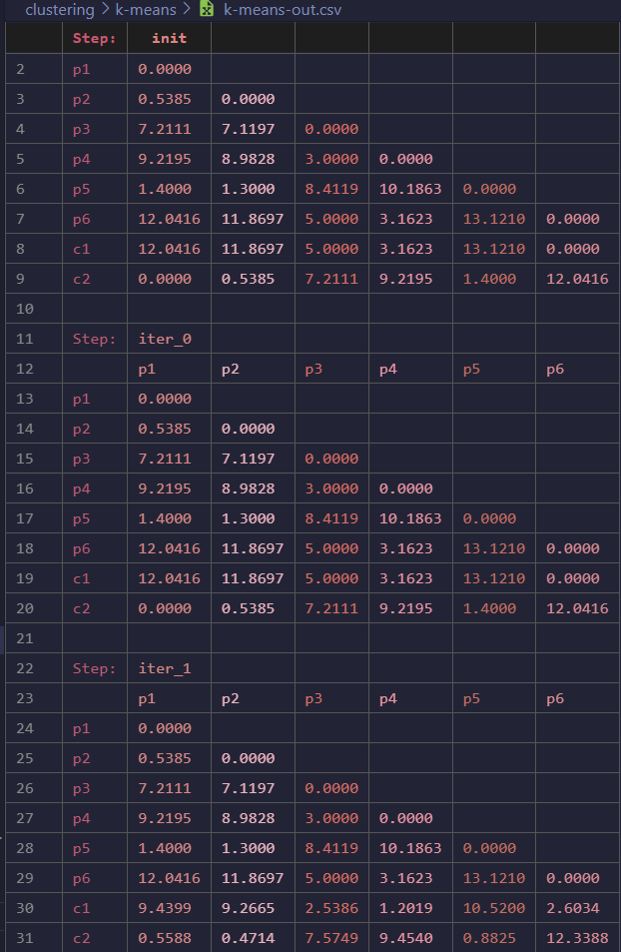
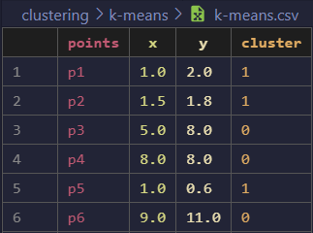
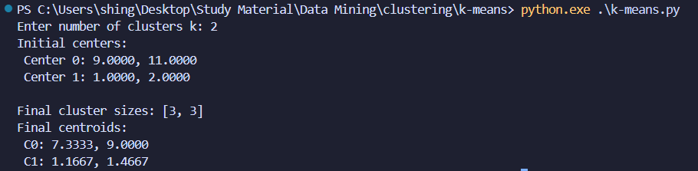
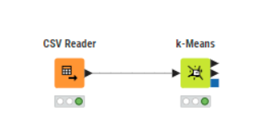
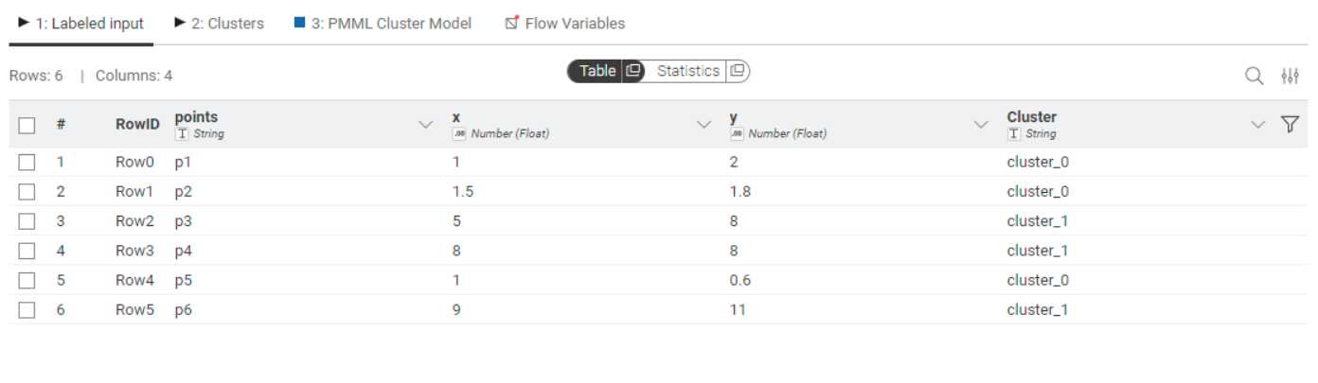
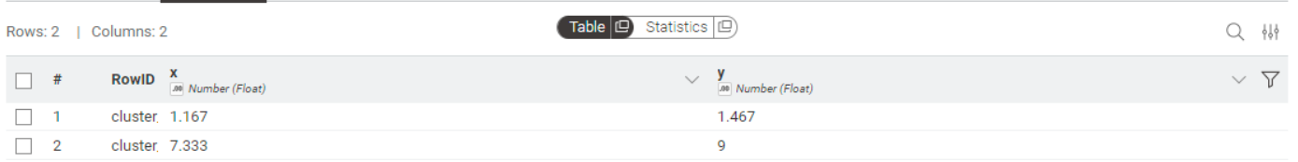
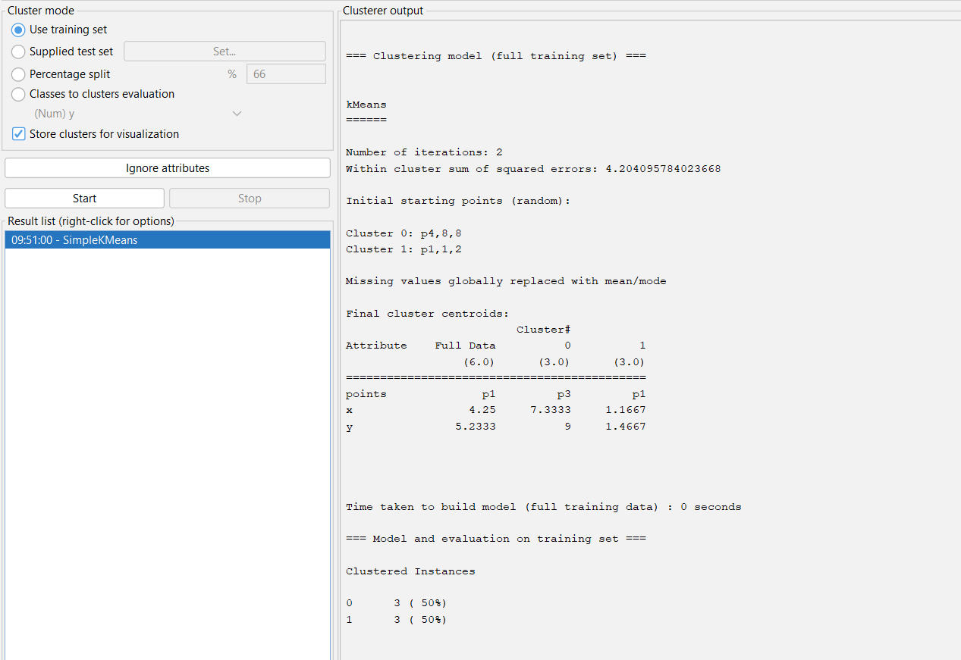

DBSCAN
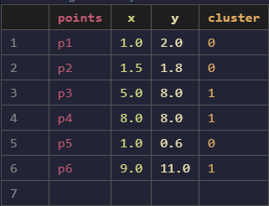
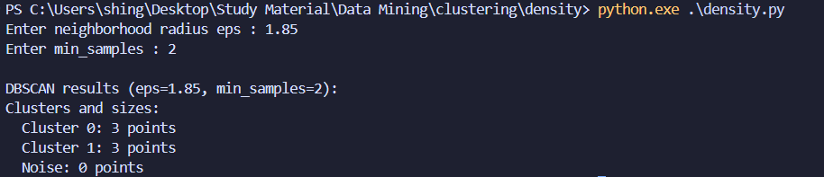
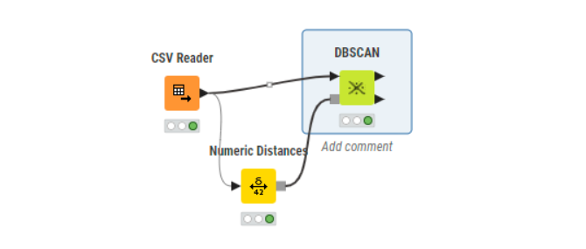
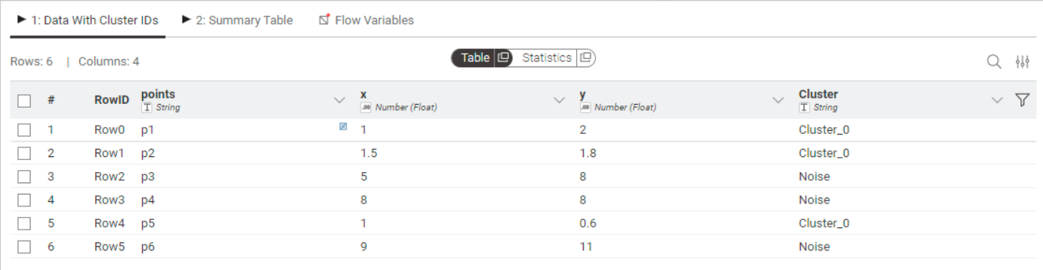
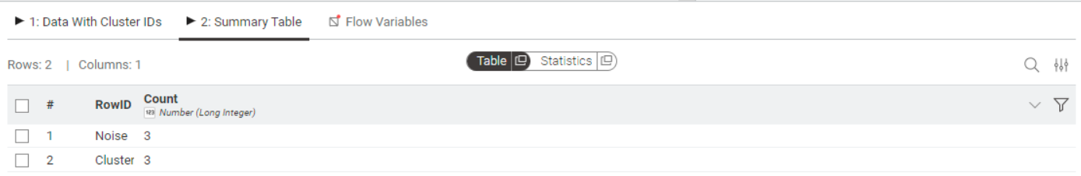
Heirarchial :
Single Linkage
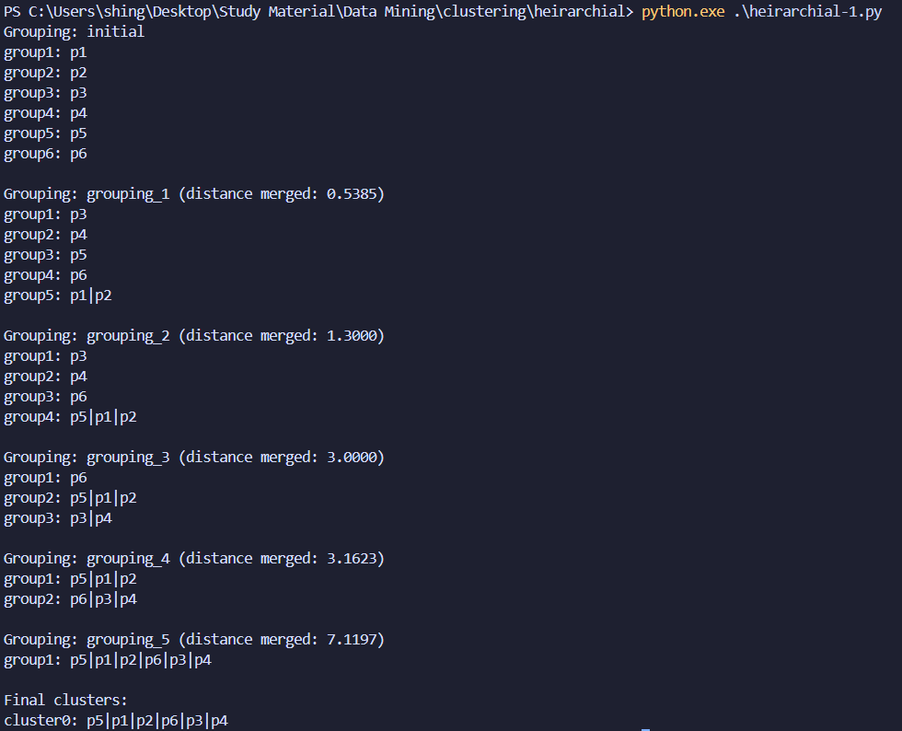
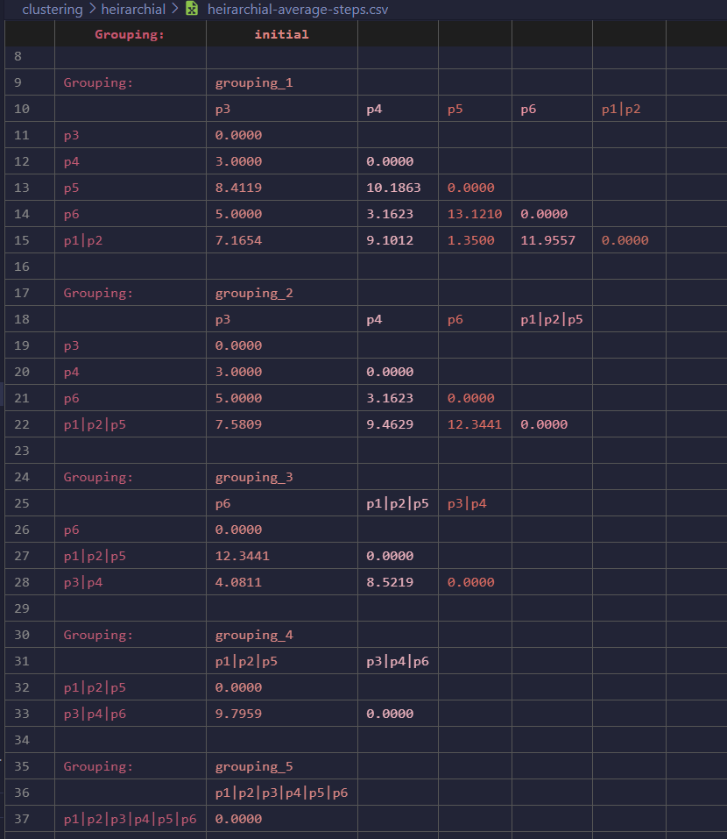
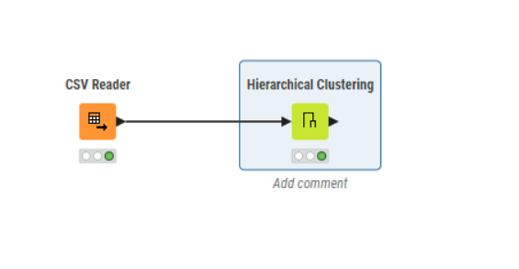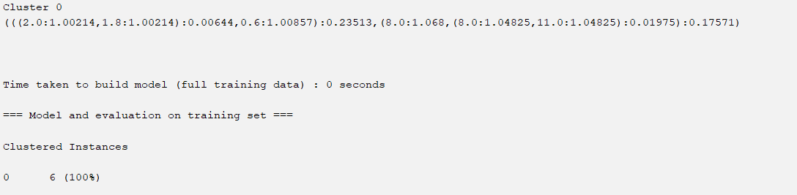
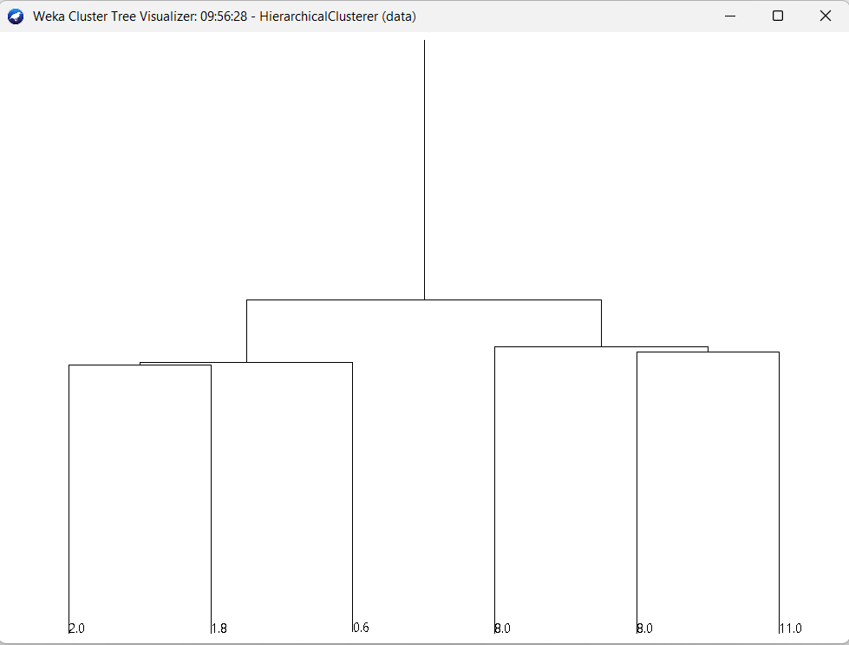
Complete Linkage:
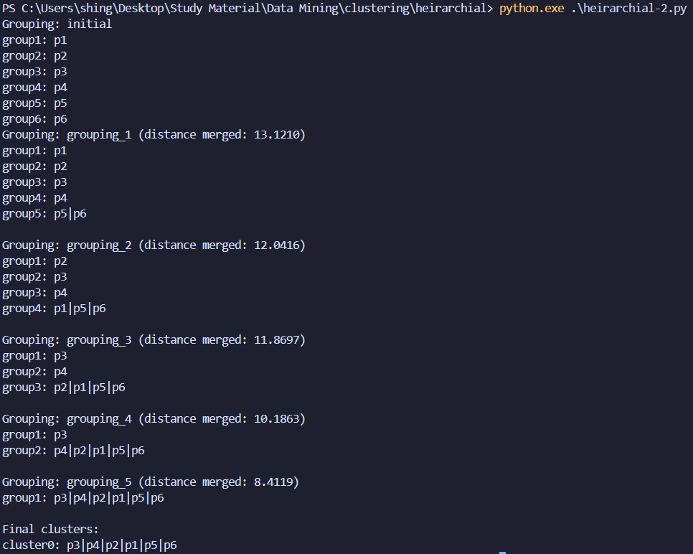
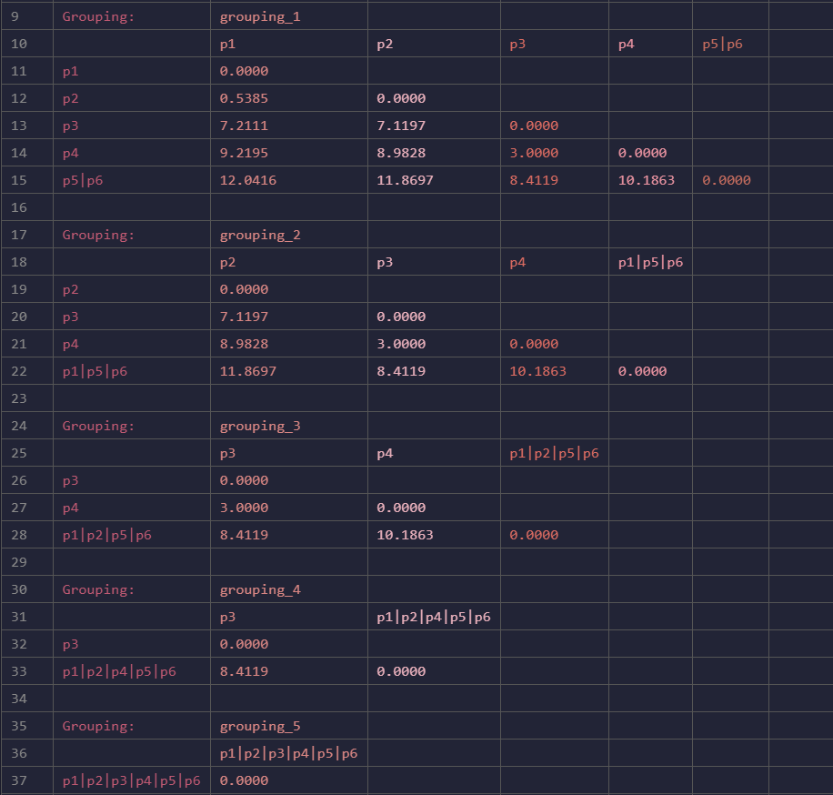
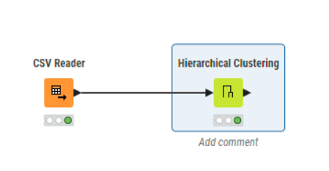
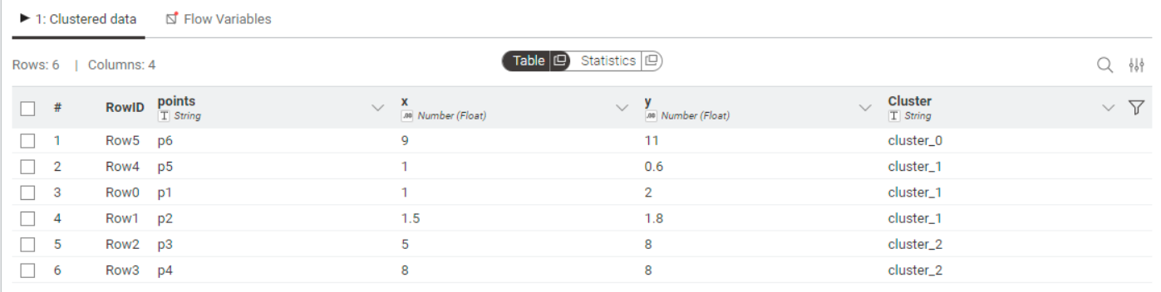
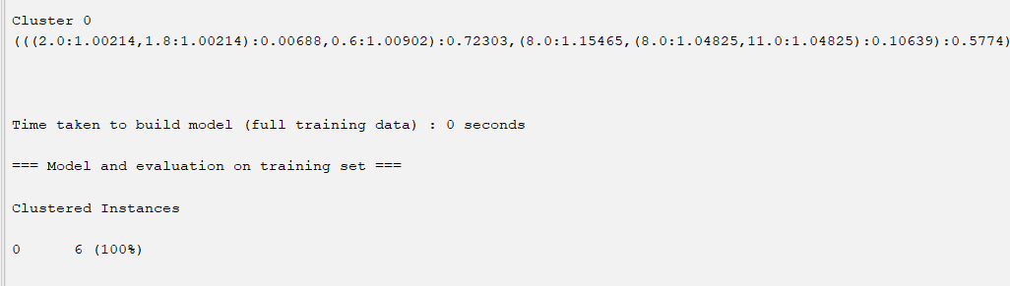
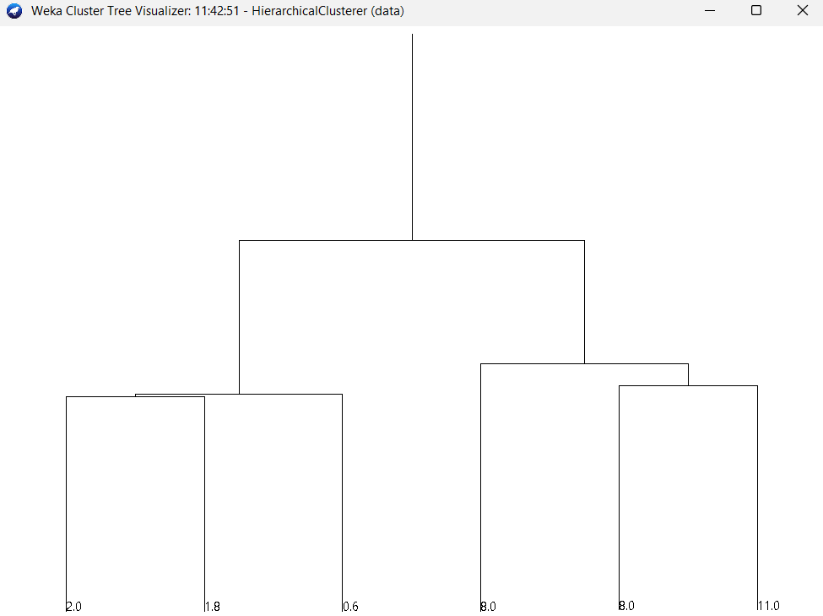
Average Linkage :
